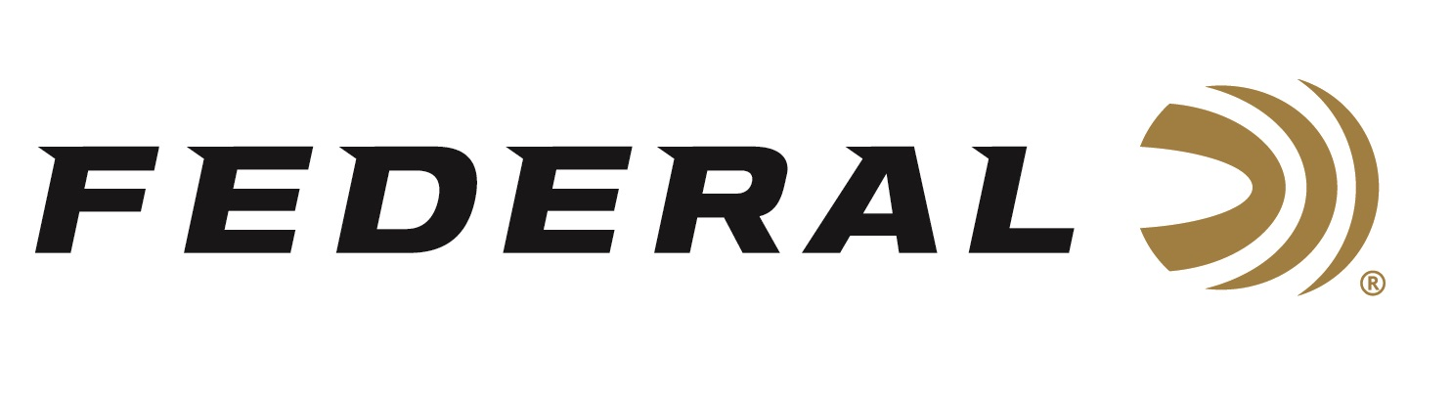

FOR IMMEDIATE RELEASE

Federal Ammunition launches “It’s Federal Season” Podcast

ANOKA, Minnesota – December 18, 2019 – Federal Ammunition is excited to announce the launching of “It’s Federal Season,” a podcast dedicated to everything ammunition. Federal is coming up on 100 years and there is a ton of information to share that is both entertaining and informational. The first episode will drop on December 19, 2019 and can be downloaded from federalpremium.com/podcast.

“This is an exciting launch and a new marketing tool for our leading ammunition brand,” says Jason Vanderbrink, President of Federal. “Our goal is to entertain, inform, and give insight into our new and existing products that you use in your practice, your hunts, and in your self-defense every day.”

Listeners can expect to learn about new products and promotions but also hear from our many partners in the hunting and shooting industry including conservation leaders, celebrities, competitive shooters, and prominent newsmakers. These conversations are going to be engaging and informative. The podcast will feature a TECH TALK segment where Federal’s engineers or product managers will go in-depth on design and performance of our category leading products and the key differentiators that separate us from the competition.

The initial podcast schedule will be dropping new content each month with the primary host being Jason Vanderbrink, President of Federal. The flexibility of the medium allows Federal to increase frequency when seasons heat up. Look for more information at www.federalpremium.com or where you find your favorite podcasts.

Press Release Contact: JJ Reich
Senior Communications Manager - Firearms and Ammunition
E-mail: VistaPressroom@VistaOutdoor.com

About Federal Ammunition
Federal, headquartered in Anoka, MN, is a brand of Vista Outdoor Inc., an outdoor sports and recreation company. From humble beginnings nestled among the lakes and woods of Minnesota, Federal Ammunition has evolved into one of the world's largest producers of sporting ammunition. Beginning in 1922, founding president, Charles L. Horn, paved the way for our success. Today, Federal carries on Horn's vision for quality products and service with the next generation of outdoorsmen and women. We maintain our position as experts in the science of ammunition production. Every day we manufacture products to enhance our customers' shooting experience while partnering with the conservation organizations that protect and support our outdoor heritage. We offer thousands of options in our Federal Premium and Federal® lines-it's what makes us the most complete ammunition company in the business and provides our customers with a choice no matter their pursuit.

